**Entity Framework Core**

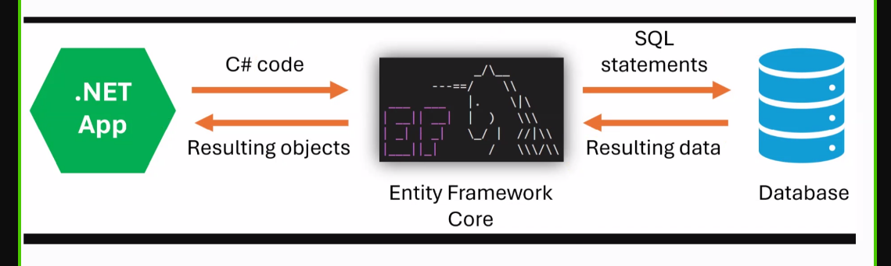

* EF **Core** is an **ORM** for .NET that connects applications to databases.
* Converts **C# code** into **SQL statements**.
* Converts **database results** into **C# objects**.
* Sits between a **.NET App** and a **Database**.
* Simplifies **data access** without writing raw SQL.
* Supports features like **LINQ**, **migrations**, and **change tracking**.
* Works with multiple databases (SQL Server, SQLite, etc.).

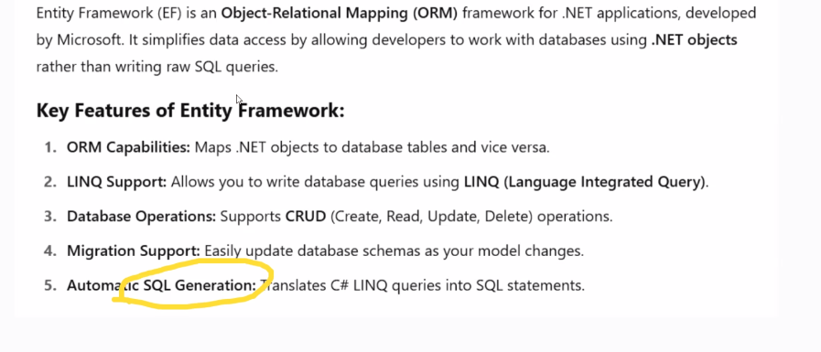

**First,**

* We create an MVC application
* We create a model student.cs and define logic for table
* Then we create a controller studentscontroller.cs with view
* Then NuGet- package manager console -type the commands:

**Commands:**

Add-Migration InitialCreate

Update-Database

* Creates an initialcreate migration folder and updates database by linking to model
* Then you have a data file, use SQL server object explorer in view to use the table
* Click on the table view for data after you run the package and type/enter the data you want
* The data Context class is the bridge between SQL and c#